**COLLEGE OF COMPUTER STUDIES**

| Name:  Angeles, Jose Kervin S.  Herrera, Antonio Rafael Munoz, Terrence Lagamon, Archie  Manzano, Jed | Date:04/23/2025 |
| --- | --- |
| Section: IT32S4  Program: BSIT | Instructor: Sir Jerry Borromeo |
| **Assessment Task: Assignment 6.3 Final Project Deliverables** | |

**Instruction:**

1. Individually, must submit the following:

a. Final Project document for a specific company discussing its network setup) DOCX

b. Packet Tracer file (.PKT) and floor plan/network layout

c. PowerPoint presentation (Prepare a pre-recorded presentation,15-20 minutes max)

**TABLE OF CONTENTS**1. Introduction (Nature of Business)  
2. Summary of Specification (Tabular form with prices)  
 2.1 Server PC (Hardware and Software)  
 2.2 Workstation PC (Hardware and Software)  
 2.3 Connectivity Devices, transmission media, and connectors  
 2.4 Other Peripherals  
3. Network Layout and Architecture  
 3.1 Network Layout (it must be in 3D)  
 3.2 Network Layout with cable run  
 3.3 Network Architecture (ex,. Client/Server, Peer-to-Peer, Cloud, etc.)  
4. IP Address Table  
5. Security Policy  
6. Appendix  
 6.1 Bibliography (books, journals, conference, www, etc.)  
 6.2 Price List  
 6.3 Resource Person (maximum of 4 persons)  
 6.4 Personal Vitae (picture, complete name, email address, contact number)  
 6.5 Group Observation (100 words minimum)  
 6.6 Individual Synthesis (100 words minimum)

1. **Introduction**
2. **Summary of Specification**

**2.1 Server PC (Hardware & Software)**

| **Item** | **Image** | **Description** | **Qty** | **Unit Price** | **Total Price** |
| --- | --- | --- | --- | --- | --- |
| Server | View PowerEdge T440 Tower Server | Dell EMC PowerEdge T440 Tower Server (Intel Xeon Silver 4210R, 32GB RAM, 2TB HDD) | 2 | ₱232,914.15 | ₱465,828.30 |
| UPS |  | APC SMT1500C UPS System (1500VA) | 2 | ₱44,955.55 | ₱89,911.10 |
| Backup Drive | Seagate Expansion Desktop Drive 8TB External HDD (Black) (STKP8000400) - DataBlitz | Seagate Expansion 8TB External Hard Drive | 2 | ₱9,928.00 | ₱19,856.00 |
| OS License | Windows Server Standard | Microsoft Windows Server 2022 Standard License (Digital) | 2 | ₱1,200.00 | ₱2,400.00 |
| **Subtotal** | | | | | **₱577,995.40** |

**2.2 Workstation PC (Hardware & Software)**

| **Item** | **Image** | **Description** | **Qty** | **Unit Price** | **Total Price** |
| --- | --- | --- | --- | --- | --- |
| Workstation |  | Recertified Dell Optiplex 7080 Micro (Intel Core i5-10500T, 16GB RAM, 256GB SSD, Windows 11 Pro) | 25 | ₱33,664.95 | ₱841,623.75 |
| Monitor | Xitrix® G2730 27" QHD 180Hz IPS Productivity Monitor | Xitrix® G2730 27" QHD 180Hz IPS Productivity Monitor | 25 | ₱11,800.00 | ₱295,000.00 |
| Office Suite | Office Home 2024 | Microsoft Office Home & Student 2021 | 25 | ₱5,499.00 | ₱137,475.00 |
| **Subtotal** | | | | | **₱1,274,098.75** |

**2.3 Connectivity Devices, Transmission Media, and Connectors**

| **Item** | **Image** | **Description** | **Qty** | **Unit Price** | **Total Price** |
| --- | --- | --- | --- | --- | --- |
| Switch |  | Cisco Business 24-Port Gigabit PoE+ Managed Switch | 2 | ₱46,425.00 | ₱92,850.00 |
| Access Point |  | Ubiquiti Access Point WiFi 6 In-Wall U6-IW-US | 2 | ₱13,207.99 | ₱26,415.98 |
| Network Cabinet |  | Data Cabinet 9U Network Cabinet | 1 | ₱1,950.00 | ₱1,950.00 |
| Patch Panel | Brand-Rex Cat6Plus Series Cat6 24 Port RJ45 LSA Patch Panel STP 1U Black | 24-Port Patch | 1 | ₱1,500.00 | ₱1,500.00 |
| Cat6 Cable |  | Genuine 100 meters RJ45 Cat6 FTP Outdoor Cable | 6 | ₱2,404.81 | ₱14,428.86 |
| RJ-45 Connectors |  | Tycon RJ45 Connector (100pcs) | 1 | ₱94.00 | ₱94.00 |
| **Subtotal** | | | | | **₱137,238.84** |

**2.4 Other Peripherals**

| **Item** | **Image** | **Description** | **Qty** | **Unit Price** | **Total Price** |
| --- | --- | --- | --- | --- | --- |
| Printer |  | Brother DCP-L2640DW Wireless Monochrome Multi-Function Laser Printer | 2 | ₱11,060.36 | ₱22,120.72 |
| CCTV System |  | Hikvision CCTV Package (8 Channel DVR, 6 Cameras, 2MP) | 1 | ₱20,831.00 | ₱20,831.00 |
| Subtotal | | | | | ₱42,951.72 |

**Grand Total: ₱2,032,284.71**

**Additionals:  
Recommendations (Not Included in Budget)**

Internet Connection: Dual Fiber Business Plans (e.g., Converge and PLDT) with at least 100 Mbps bandwidth each for redundancy.

Air-Conditioning Unit:

1.5 HP Split Type Dual Inverter Aircon for server room and work areas.

**Additional Peripherals:**

Networked Projector or Smart TV for conference rooms.

External NAS for additional backup solutions.

Wireless keyboards and mice for shared workstations.

1. **Network Layout And Architecture**
   1. **Network Layout**

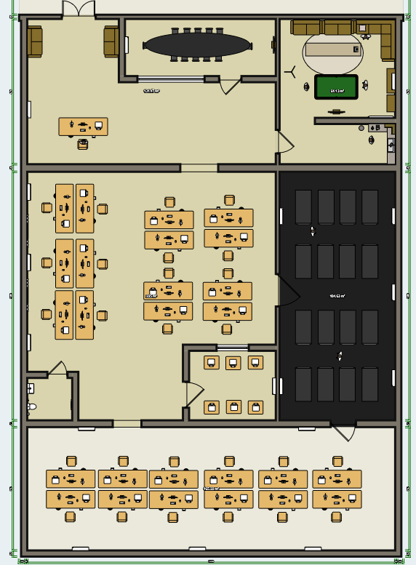

* + 1. **Garage**

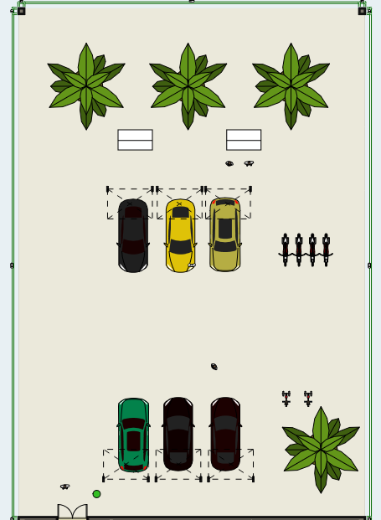

* 1. **3D View**
     1. **Garage Area**

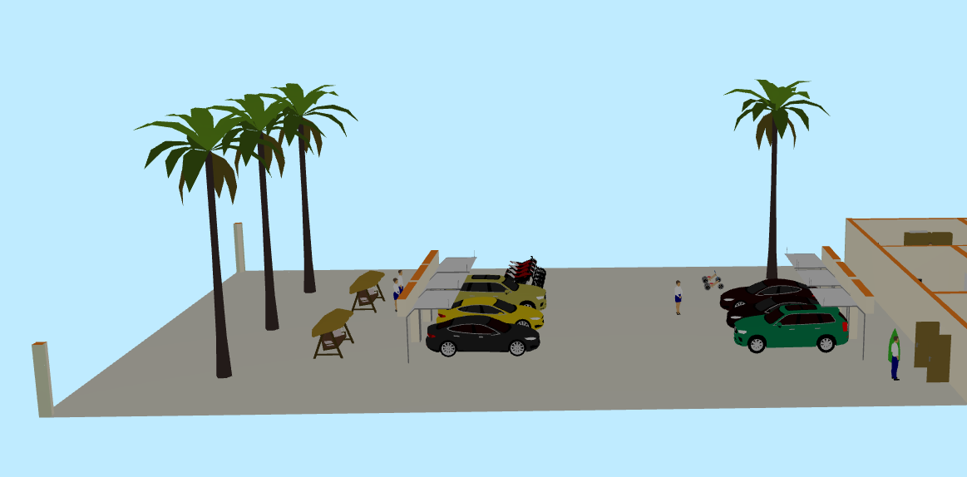

* + 1. **Reception Area**

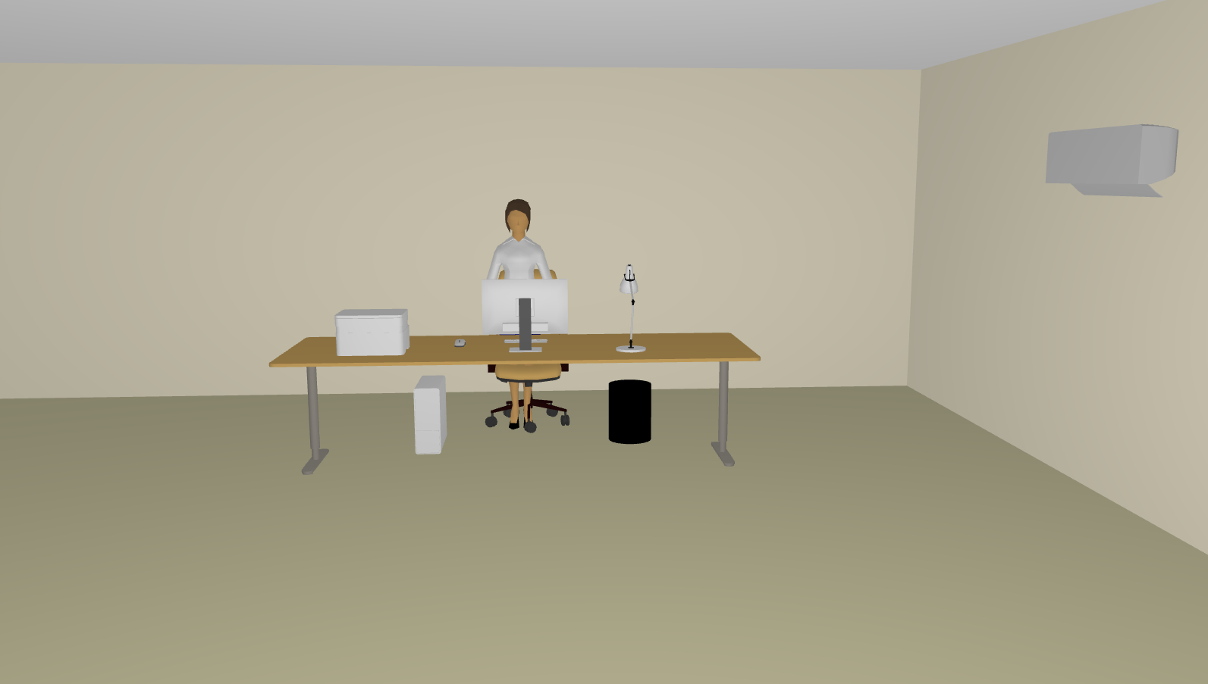

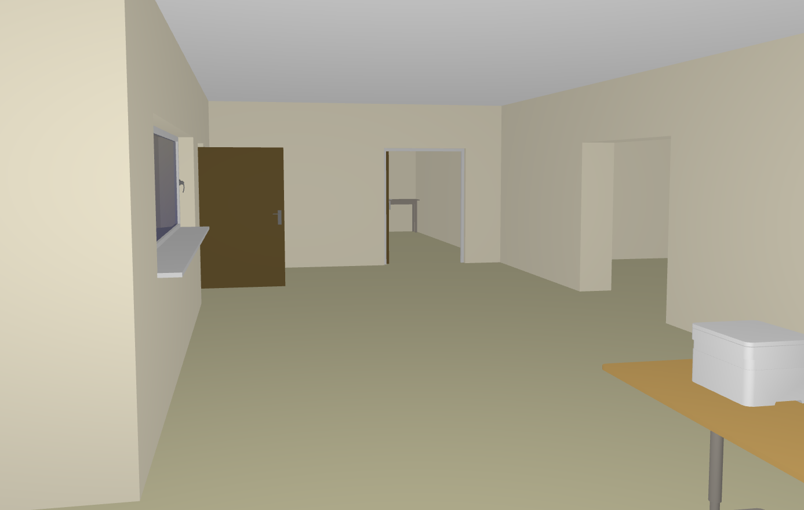

* + 1. **Meeting Room**

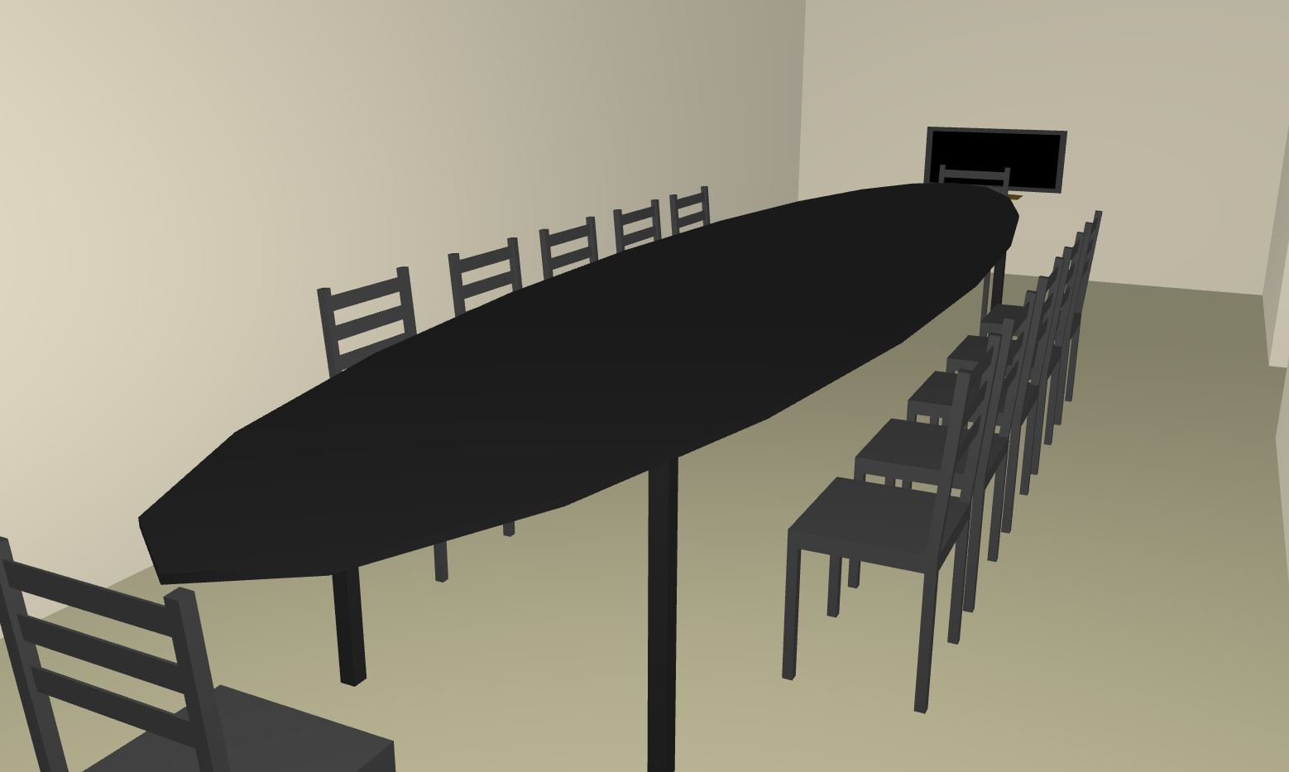

* + 1. **Break Room**

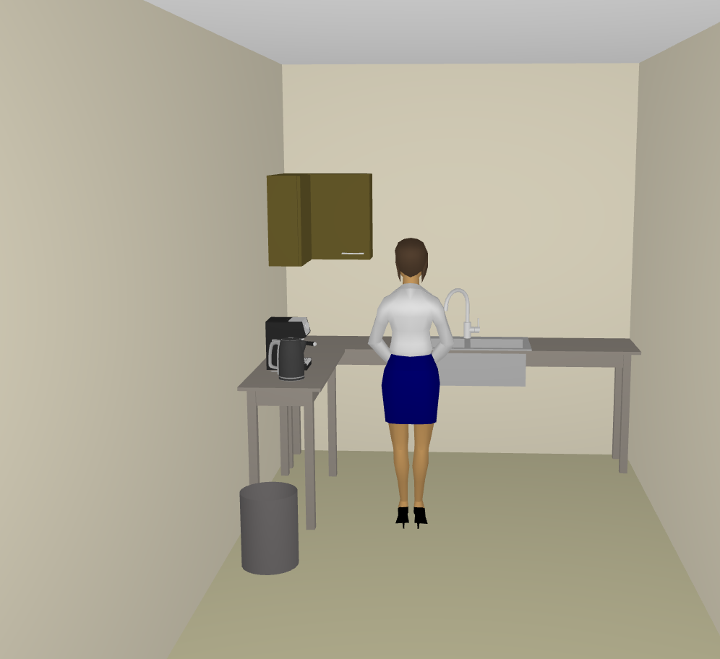

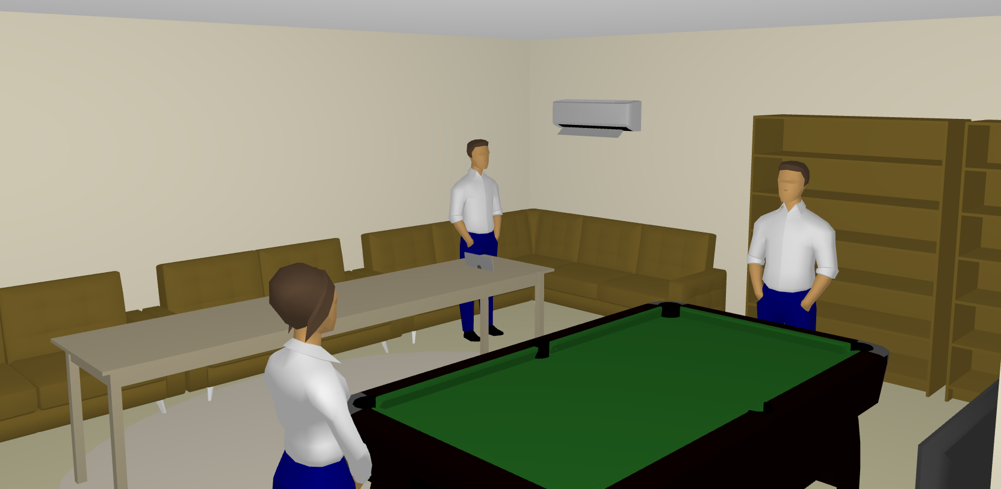

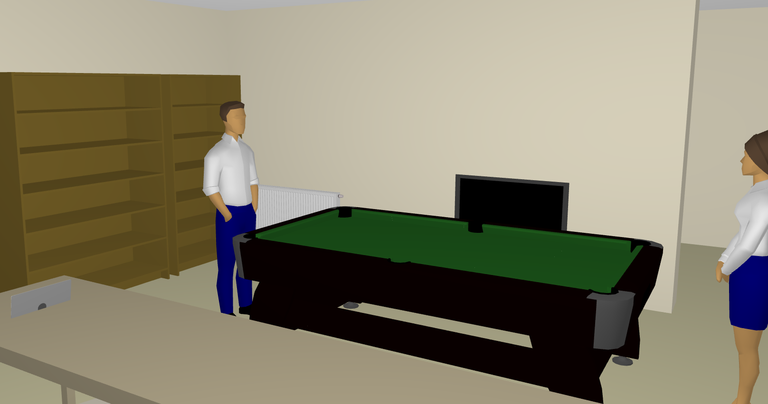

* + 1. **Print Server Workstations**

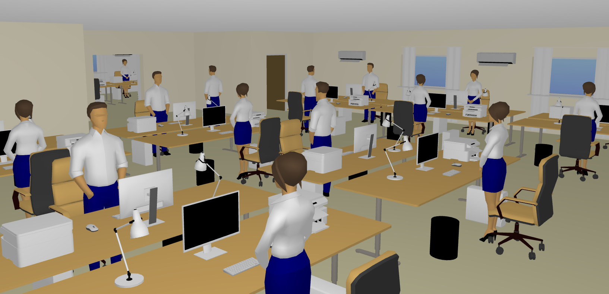

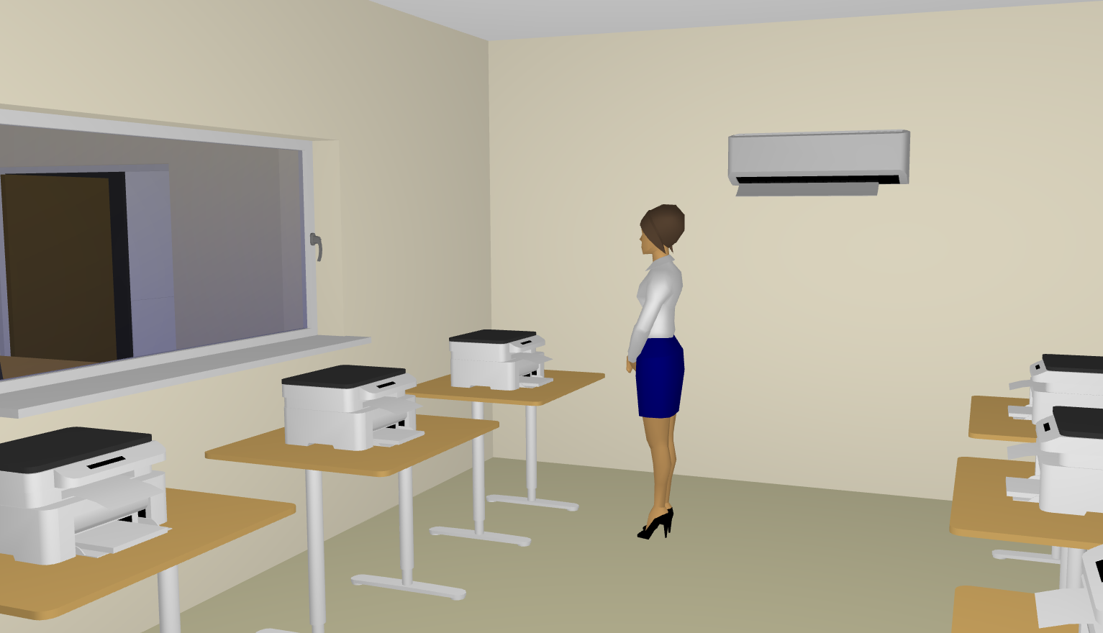

* + 1. **File Server Workstation**

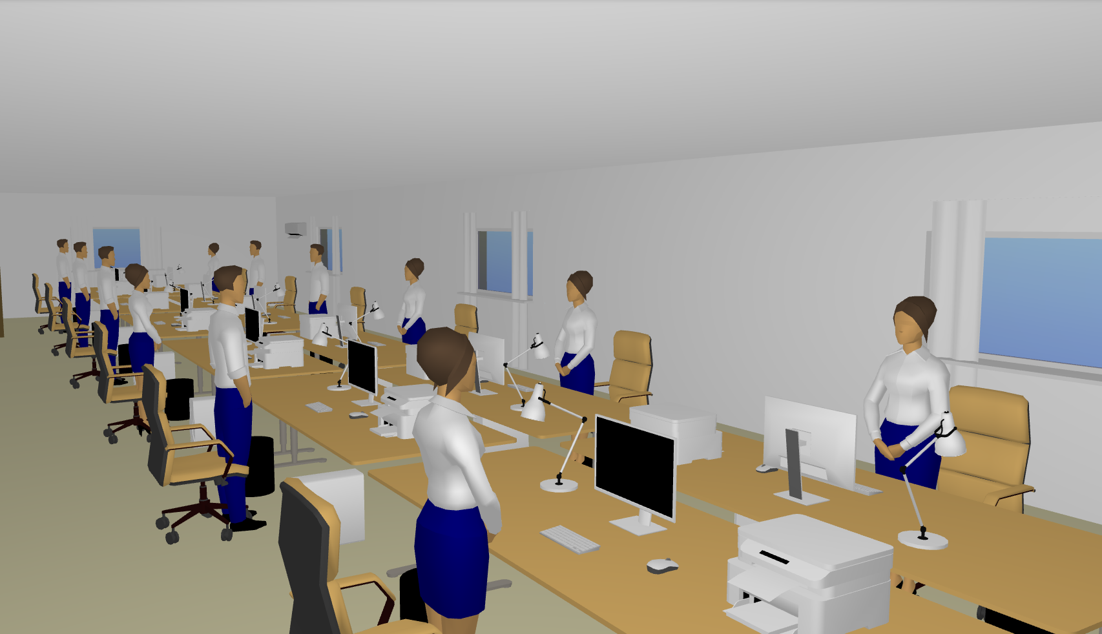

* + 1. **Server Room**

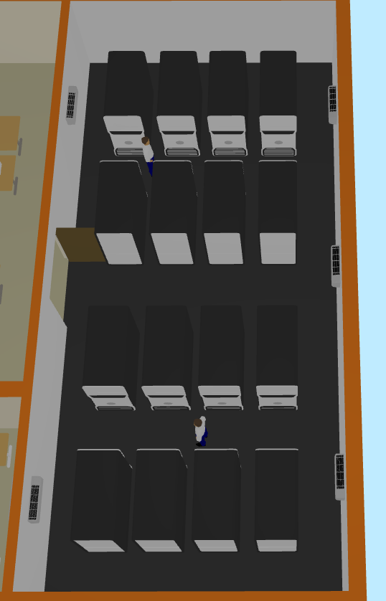

* 1. **Network Layout with Cable Run**
  2. **Network Architecture**

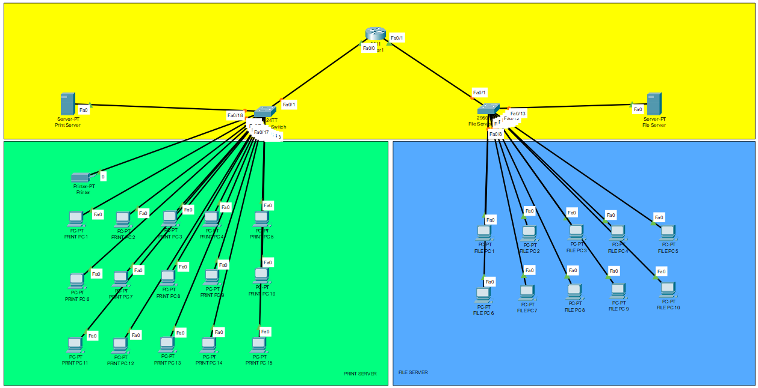

1. **IP Address Table**

| **Device Name** | **Interface** | **IP Address** | **Subnet Mask** | **Default Gateway** | **DNS** |
| --- | --- | --- | --- | --- | --- |
| Router | Fa0/0 | 192.168.10.1 | 255.255.255.0 | **– – –** | 8.8.8.8 |
| Fa0/1 | 192.168.20.1 |
| Print Server Switch | Fa0/0 - Fa0/18 | **– – –** | **– – –** | **– – –** | **– – –** |
| Print Server | Fa 0/0 | 192.168.10.100 | 255.255.255.0 | 192.168.10.1 | 8.8.8.8 |
| Printer | Fa0/0 | 192.168.10.101 | 255.255.255.0 | 192.168.10.1 | 8.8.8.8 |
| File Server Switch | Fa 0/0 - Fa 0/13 | **– – –** | **– – –** | **– – –** | **– – –** |
| PRINT PC 1 - PRINT PC 15 | Fa0/0 | 192.168.10.2 - 192.168.10.16 | 255.255.255.0 | 192.168.10.1 | 8.8.8.8 |
| File Server | Fa0/0 | 192.168.20.100 | 255.255.255.0 | 192.168.20.1 | 8.8.8.8 |
| FILE PC 1 - FILE PC 10 | Fa0/0 | 192.168.20.2 - 192.168.10.11 | 255.255.255.0 | 192.168.20.1 | 8.8.8.8 |

1. **Security Policy**

1. **Appendix**
   1. **Bibliography**

*Dell PowerEdge T440 Tower Server | Asianic Distributors Inc. Philippines*. (n.d.).

<https://asianic.com.ph/product/dell-poweredge-t440-tower-server>

*Amazon.com: APC 1500VA Smart UPS with SmartConnect, SMT1500C Sinewave UPS Battery Backup, AVR, 120V + Network Cable + Wire Ties : Electronics*. (2025). Amazon.com.

<https://www.amazon.com/APC-SmartConnect-SMT1500C-Sinewave-Battery/dp/B0CPYQGR97>

‌*Seagate Expansion Desktop Drive 8TB External HDD (Black) (STKP8000400)*. (2022). DataBlitz.

<https://ecommerce.datablitz.com.ph/products/seagate-expansion-desktop-drive-8tb-external-hdd-black-stkp8000400>

‌*Windows Server 2022 Standard CAL*. (2022). Microsoft Store.

<https://www.microsoft.com/en-us/d/windows-server-2022-standard-cal/dg7gmgf0d6m5?msockid=1a12d72195f768e639e0c28e94e3690b&activetab=pivot:overviewtab>

*Amazon.com: Dell OptiPlex 7080 Micro Form Factor Mini Business Desktop, Intel Core i5-10500T Processor, 16GB RAM, 512GB SSD, RJ45, Type-C, DisplayPort, Wi-Fi 6, Windows 11 Pro : Electronics*. (2025). Amazon.com.

<https://www.amazon.com/Dell-7080-i5-10500T-Processor-DisplayPort/dp/B0BWSHGZS7?th=1>

(2025). Lazada.com.ph.

<https://www.lazada.com.ph/products/xitrix-g2730-27inch-180hz-ips-wqhd-2560-x-1440-wide-screen-display-1440p-flat-productivity-gaming-monitor-height-adjustable-stand-free-displayport-cable-3-years-warranty-i4291345881.html>

*Buy Microsoft Office Home & Student 2021 - Computech Store*. (2025, May). Computech Store.

<https://computechstore.in/product/microsoft-office-home-student-2021/>

*Amazon.com: Cisco Business CBS350-24P-4G Managed Switch | 24 Port GE | PoE | 4x1G SFP | Limited Lifetime Protection (CBS350-24P-4G-NA : Electronics*. (2025). Amazon.com.

<https://www.amazon.com/CISCO-DESIGNED-CBS350-24P-4G-Protection-CBS350-24P-4G-NA/dp/B08HY976WF?th=1>

‌*Access Point U6 In-Wall*. (2025). Ubiquiti Store .

<https://store.ui.com/us/en/products/u6-iw>

‌(2025). Lazada.com.ph.

<https://www.lazada.com.ph/products/9u-data-cabinet-600mm-450mm-wall-mountable-network-cabinet-disassembled-data-rack-without-accessories-i583366391.html>

‌(2025). Lazada.com.ph.

<https://www.lazada.com.ph/products/d-link-24-ports-patch-panel-cat6-fully-loaded-1ru-24-port-patch-panel-cat6-npp-c61blk241-i612472538.html>

‌(2025). Shopee.ph.

<https://shopee.ph/100M-Outdoor-Lan-Cable-Cat6-Gigabit-Utp-Cable-Patch-Cord-Cat6E-With-Metal-Shielded-Rj45-100-Meters-i.65236238.7653661879>

‌(2025). Lazada.com.ph.

<https://www.lazada.com.ph/products/100pcs-amp-tyco-rj45-connector-network-cat5-i1928175.html>

‌*DCP-L2640DW Laser Printer | Brother Philippines*. (2016). Brother.com.ph.

<https://www.brother.com.ph/en/printers/all-printers/dcp-l2640dw>

PC Express. (2025, April 30). *HIKVISION TVI-8CH4D4B-2MP ECO 8CH HDTVI Combo Kit*. PC Express.

<https://pcx.com.ph/products/hikvision-tvi-8ch4d4b-2mp-eco-8ch-hdtvi-combo-kit>

* 1. **Price List**

| **Item** | **Image** | **Description** | **Qty** | **Unit Price** | **Total Price** |
| --- | --- | --- | --- | --- | --- |
| Server | View PowerEdge T440 Tower Server | Dell EMC PowerEdge T440 Tower Server (Intel Xeon Silver 4210R, 32GB RAM, 2TB HDD) | 2 | ₱232,914.15 | ₱465,828.30 |
| UPS |  | APC SMT1500C UPS System (1500VA) | 2 | ₱44,955.55 | ₱89,911.10 |
| Backup Drive | Seagate Expansion Desktop Drive 8TB External HDD (Black) (STKP8000400) - DataBlitz | Seagate Expansion 8TB External Hard Drive | 2 | ₱9,928.00 | ₱19,856.00 |
| OS License | Windows Server Standard | Microsoft Windows Server 2022 Standard License (Digital) | 2 | ₱1,200.00 | ₱2,400.00 |
| **Subtotal** | | | | | **₱577,995.40** |

| **Item** | **Image** | **Description** | **Qty** | **Unit Price** | **Total Price** |
| --- | --- | --- | --- | --- | --- |
| Workstation |  | Recertified Dell Optiplex 7080 Micro (Intel Core i5-10500T, 16GB RAM, 256GB SSD, Windows 11 Pro) | 25 | ₱33,664.95 | ₱841,623.75 |
| Monitor | Xitrix® G2730 27" QHD 180Hz IPS Productivity Monitor | Xitrix® G2730 27" QHD 180Hz IPS Productivity Monitor | 25 | ₱11,800.00 | ₱295,000.00 |
| Office Suite | Office Home 2024 | Microsoft Office Home & Student 2021 | 25 | ₱5,499.00 | ₱137,475.00 |
| **Subtotal** | | | | | **₱1,274,098.75** |

| **Item** | **Image** | **Description** | **Qty** | **Unit Price** | **Total Price** |
| --- | --- | --- | --- | --- | --- |
| Switch |  | Cisco Business 24-Port Gigabit PoE+ Managed Switch | 2 | ₱46,425.00 | ₱92,850.00 |
| Access Point |  | Ubiquiti Access Point WiFi 6 In-Wall U6-IW-US | 2 | ₱13,207.99 | ₱26,415.98 |
| Network Cabinet |  | Data Cabinet 9U Network Cabinet | 1 | ₱1,950.00 | ₱1,950.00 |
| Patch Panel | Brand-Rex Cat6Plus Series Cat6 24 Port RJ45 LSA Patch Panel STP 1U Black | 24-Port Patch | 1 | ₱1,500.00 | ₱1,500.00 |
| Cat6 Cable |  | Genuine 100 meters RJ45 Cat6 FTP Outdoor Cable | 6 | ₱2,404.81 | ₱14,428.86 |
| RJ-45 Connectors |  | Tycon RJ45 Connector (100pcs) | 1 | ₱94.00 | ₱94.00 |
| Subtotal | | | | | ₱137,238.84 |

| **Item** | **Image** | **Description** | **Qty** | **Unit Price** | **Total Price** |
| --- | --- | --- | --- | --- | --- |
| Printer |  | Brother DCP-L2640DW Wireless Monochrome Multi-Function Laser Printer | 2 | ₱11,060.36 | ₱22,120.72 |
| CCTV System |  | Hikvision CCTV Package (8 Channel DVR, 6 Cameras, 2MP) | 1 | ₱20,831.00 | ₱20,831.00 |
| **Subtotal** | | | | | **₱42,951.72** |

* 1. **Resource Person**
  2. **Personal Vitae**

| **Picture** | **Name** | **Email** | **Contact** | **Contribution** |
| --- | --- | --- | --- | --- |
|  | **Angeles, Kervin** |  |  |  |
|  | **Herrera, Antonio Rafael** |  |  |  |
|  | **Lagamon, Archie** | **qalagamon**  **@tip.edu.ph** | **0945 116 1914** | * **Helped in hardware specs.** * **Bibliography** * **Price list** * **Group observation** |
|  | **Manzano, Jed** |  |  |  |
|  | **Munoz, Terence** |  |  |  |

* 1. **Group Observation**

Linked BPO has built a functional IT system that enables daily recruitment services for Australian health care and child care sector clients. The network operation requiresHardware basics including 48-port switches, Wi-Fi mesh systems and customized workstations which cost somewhere between ₱1.5M and ₱2M to support 40 employees. A single Systems Administrator manages the entire IT infrastructure while enforcing policy but such an organizational structure might reduce expansion possibilities. Hardware and software maintenance requiring upgrades represents a crucial challenge since the team expands in size. The current data privacy and basic backup policies exist but the organization needs to invest more effort in enhancing its cybersecurity infrastructure. The company implements productive IT practices although they could develop their security measures and their ability to expand operations.

Strengths:

* Clear hierarchy with a dedicated Systems Administrator.
* The company implements a complete system of security protocols along with data backup systems and data privacy regulations.
* The company maintains an adaptive infrastructure system that maintains flexibility to adapt to workforce size expansion.

Challenges:

* The company demands regular upgrades for its equipment together with its software to sustain high performing operations.
* The workforce expansion requires better internet connectivity because it depends on it for operations.
  1. **Individual Synthesis**

**Lagamon, Archie Q.**

The IT infrastructure at Linked BPO functions effectively for present operations through funding of PHP 1.5M–2M which covers 40 workstations and their associated hardware. System reliability and security maintenance depends heavily on the Systems Administrator team to function properly. The company will face network scalability challenges alongside software modernization demands which will need strategic funding after its growth phase. A strong security policy exists within Linked BPO but regular audits along with employee training sessions would enhance its protective capabilities.